ABSTRACT REGARDING HACKERVERSE -2021
THEME: Climate Change

Vehicle pollution due to fuel emission is identified as the major factor in climate change. And by EV (electric vehicles) giving major competetion the market of EV is going to be the new future of the automobile industry.
Our product BE INCHARGE is majorly focused on providing the wireless charging to the EV in major public areas. Like malls, corporate offices etc. This will lead in hassle free charging for ev and which may add a great impact in making country less fuel focused and more people will be encouraged in making investment in ev

concept used for wireless charging is :

NEAR-FIELD WIRELESS POWER TRANSFER TECHNOLOGY
Near-field WPT systems are of two types: inductive, which use magnetic field coupling between conducting coils, and capacitive, which use electric field coupling between conducting plates to transfer energy . For medium-range applications (in which the distance between the transmitter and the receiver couplers is comparable to the size of the couplers, as in EV charging), inductive WPT systems have traditionally been preferred.
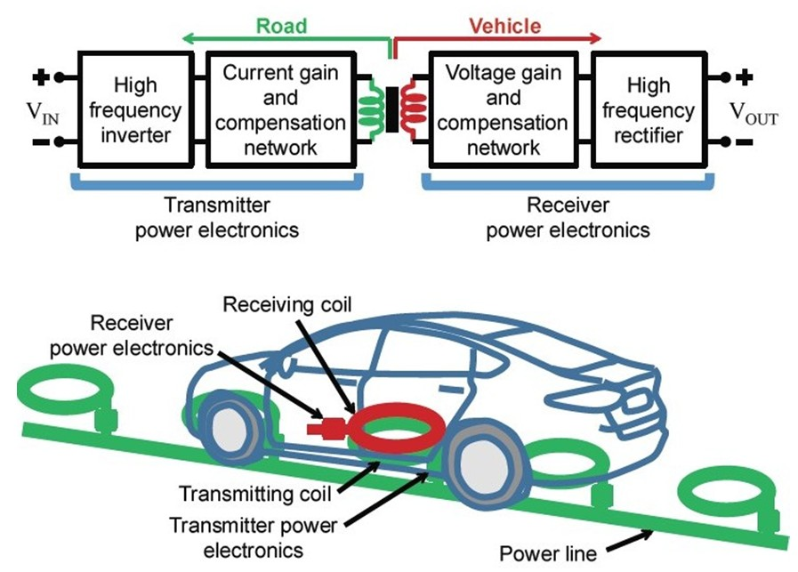
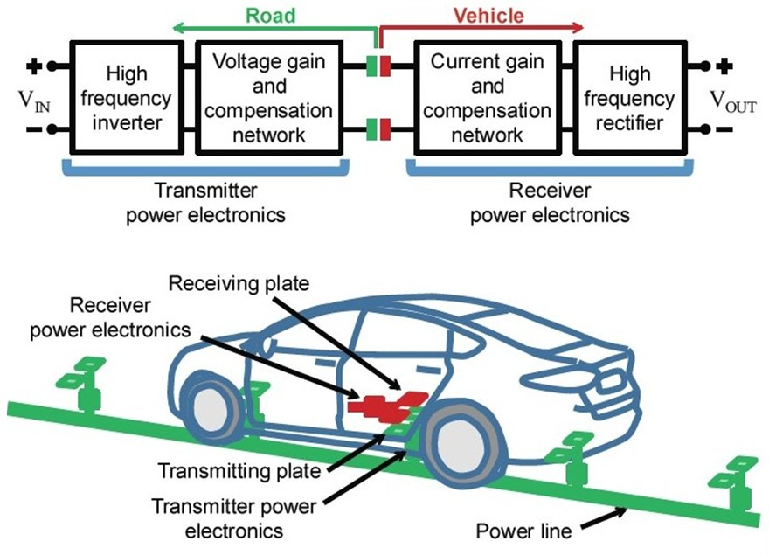
1. Physical implementation (left) and block diagram representation (right) of two approaches to deliver energy wirelessly to electric vehicles from an electrified roadway: (a) inductive wireless power transfer (WPT) using coils (embedded in the roadway and in the vehicle) that are coupled through magnetic fields, and (b) capacitive WPT using plates coupled through electric fields. In both cases, power electronics (comprising a high-frequency inverter and rectifier with semiconductor devices, and gain and compensation networks with inductors, capacitors, and/or transformers) is the enabling technology.

Inductive WPT Systems
Building on work done for material handling applications during the 1990s (Green and Boys 1994), the past decade has seen tremendous progress in inductive WPT technology for stationary charging of EVs (Bosshard and Kolar 2016). Aftermarket stationary chargers are already available, and some EV manufacturers have announced plans to introduce built-in stationary inductive WPT systems as early as 2018.
However, for magnetic flux guidance and shielding, inductive WPT systems require ferrite cores, making them expensive and bulky. Also, to limit losses in the ferrites, the operating frequencies of these systems are kept under 100 kHz, resulting in large coils and low power transfer densities. The high cost and low power transfer density are particularly problematic for dynamic WPT, as these systems need to have very high power capability to deliver sufficient energy to the vehicle during its very brief time passing over a charging coil.
For these reasons dynamic inductive WPT is yet to become commercially viable, although a few experimental systems have been demonstrated (Choi et al. 2015; Onar et al. 2013).
Capacitive WPT Systems
Capacitive WPT systems have potential advantages over the inductive systems because of the relatively directed nature of electric fields, which reduces the need for electromagnetic field shielding. Also, because capacitive WPT systems do not use ferrites, they can be operated at higher frequencies, allowing them to be smaller and less expensive. Capacitive WPT could thus make dynamic EV charging a reality.
But because of the very small capacitance between the road and vehicle plates, effective power transfer can occur only at very high frequencies, making the design of these systems extremely challenging. With the recent availability of wide-bandgap (gallium nitride [GaN] and silicon carbide [SiC]) power semiconductor devices that enable higher-frequency operation, high-power medium-range capacitive WPT systems are becoming viable (Regensburger et al. 2017; Zhang et al. 2016).
Two major challenges associated with capacitive WPT for EV charging are (1) achieving high-power transfer density at high efficiencies while meeting electromagnetic safety requirements, and (2) maintaining effective power transfer even as the couplers’ relative position changes. These challenges have been a focus of my group’s recent efforts.

